Qpid Management Console

Revision History
Date | Author | Summary
05th Jan 2007 | Bhupendra Bhardwaj | Initial draft
28th Apr 2007 | Bhupendra Bhardwaj | -Implemented Virtual Hosts  -Implemented User Login  -User preferences (browsed Queues/Exchanges/Connections) will be saved.

Table of Contents

1. Introduction 4
2. Add Server: 4
2.1 Adding a Managed Object for Monitoring: 5
3. Disconnect/Reconnect/Remove a server: 6
4. Virtual Host Manager: 6
4 Browsing a Queue: 7
4.1 Executing an Operation: 9
5 Browsing an Exchange: 10
6 Browsing a Connection: 11

Introduction

Qpid Management Console is a GUI for Qpid broker users. A Qpid server can be monitored and managed using this Console. A user can specify threshold values for managed attributes on the server and also receive notifications when monitored values exceed those threshold values.

Following features are available for a user to monitor and manage Qpid server-
  - Add a server for monitoring
  - Browse a Queue for messages and monitor activities on the Queue
  - Browse an Exchange and create bindings for an Exchange
  - Browse a Connection and monitor channel activities

Add Server:

Click the “New Connection” menu item or Icon to add a new Qpid server for monitoring. The following screen pops up when a new connection is being added.
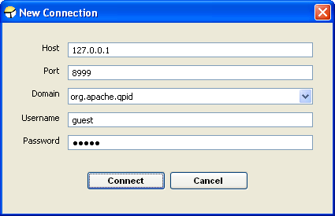

Enter all the required details and click “Connect”. Once the Qpid server gets connected, the server will be listed on the navigation frame.

Adding a Managed Object for Monitoring:

Select a type (e.g. Connection, Exchange or Queue) to list all the managed objects under that type. The list will be displayed on the right hand side. Then select the managed objects you want to monitor and “add to Navigation”.
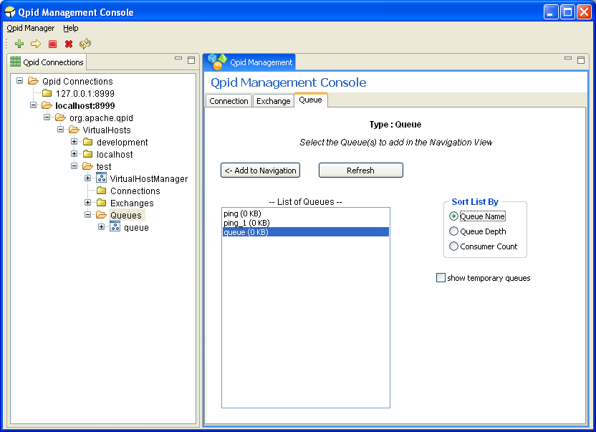

Disconnect/Reconnect/Remove a server:

To disconnect a connected server, you can select the “Disconnect” menu item from menu “Qpid Manager” or select the icon from the tool bar.

To connect the disconnected server, you can select the “Reconnect” menu item from menu “Qpid Manager” or select the icon from the tool bar.

To remove the server from the navigation frame, you can select the “Remove Connection” menu item from menu “Qpid Manager” or select the icon from the tool bar.

Virtual Host Manager:

Each Virtual Host has a Virtual Host Manager. For all managed objects, the operations are available as tabs. Using these Manager Operations, a user can perform following tasks-
- Queues can be created and/or deleted.
- Exchanges can be created and unregistered from broker.
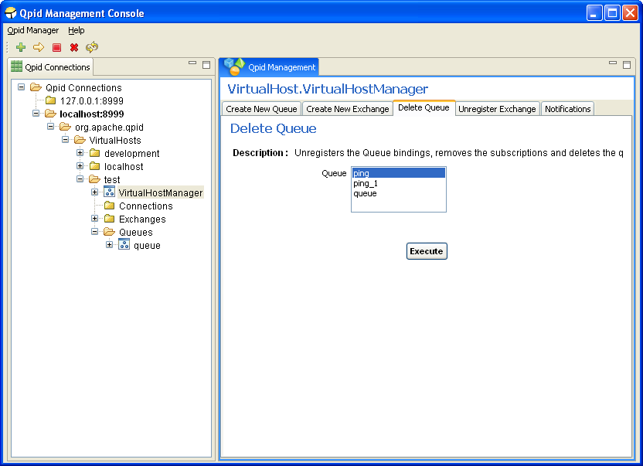

Browsing a Queue:

If you select a Queue from navigation frame, the Queue properties will be displayed. You can either click the “Details” button to see the attribute details or if you take your cursor over the attribute on this table, the attribute description will popup. To set the threshold value for editable attributes, select the attribute and click the “Edit Attribute” button. This can also be done by selecting the “Edit Attribute” menu option.

Each Queue operation is available on a tab. Using these operations you can manage and monitor the activities on the Queue.

Using Notification tab, the user can subscribe to notifications emitted by the Queue.

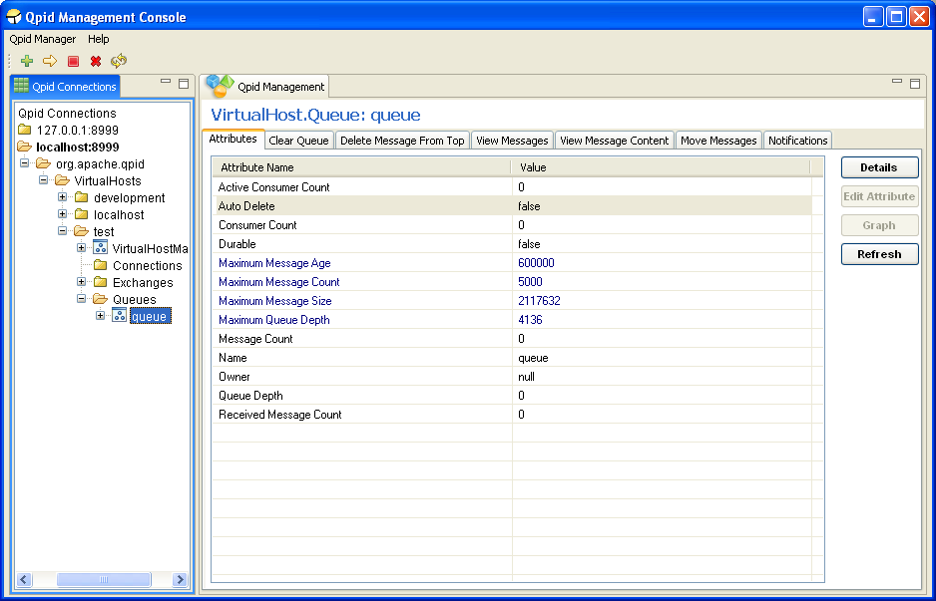

Some Queue attributes can be viewed as graph, depicting values over a period of few seconds (e.g. Message Count, Queue depth)

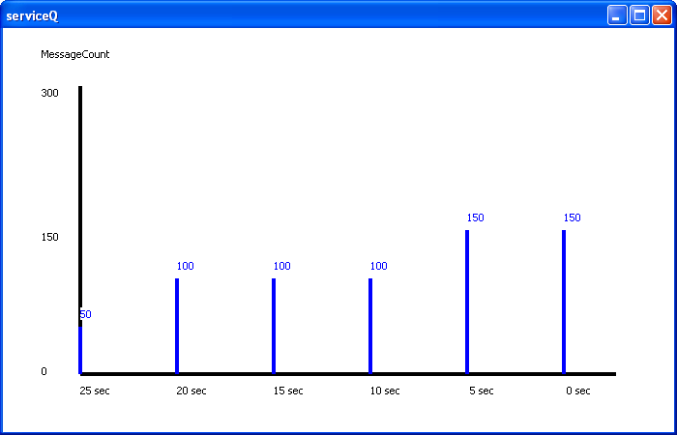

Executing an Operation:

To execute a Queue operation, select the corresponding tab and enter the required parameter values.
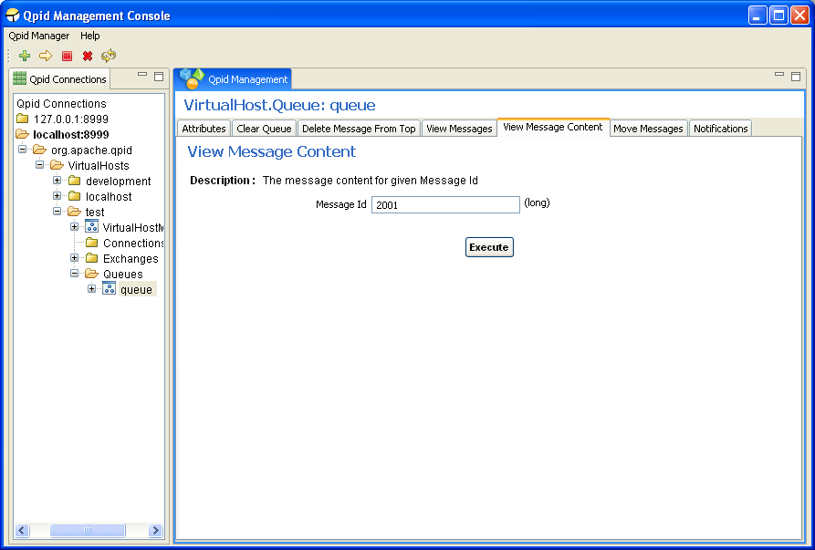
E.g. Following screen will be displayed and when the “View Message Content” operation tab is selected. Enter the message id and select “Execute”, the message content will pop-up as a separate window.

Browsing an Exchange:

If you select an Exchange from the navigation frame, the Exchange attributes will be displayed.

To “Create New Binding” for the selected Exchange, select the corresponding tab and enter the required data and then click “Execute”.
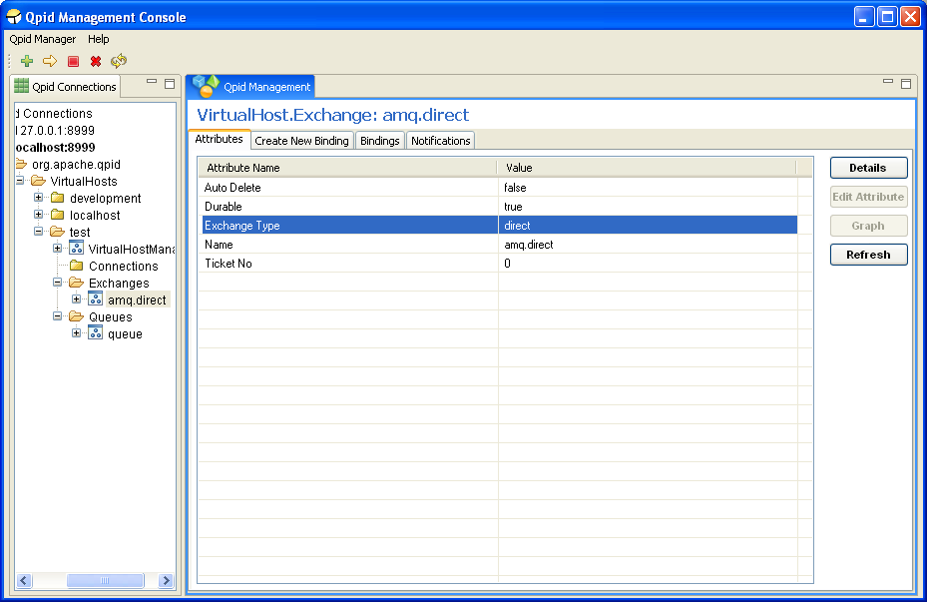
To execute an operation, steps are same as described above in executing a Queue operation.

Browsing a Connection:

To monitor the activities on a Connection, you can add the Connection to the navigation page and then select it. If you select a Connection the attributes get displayed.

All operations and Notifications to subscribe are available as tabs on the Management page.

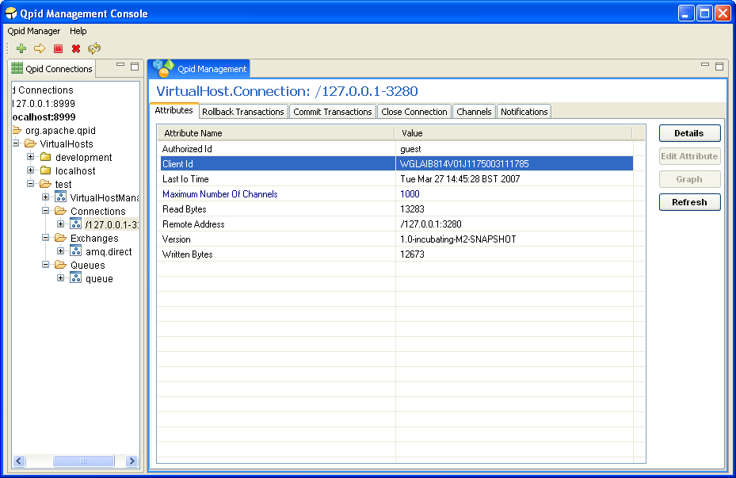
To execute an operation, steps are same as described above in executing a Queue operation.

Channels associated with the Connection can also be browsed using the “Channels” tab. A Channel corresponds to a session associated with the Connection.

